<https://central.sonatype.com/artifact/com.drewnoakes/metadata-extractor/2.18.0/overview?smo=true>

<dependency>

<groupId>com.drewnoakes</groupId>

<artifactId>metadata-extractor</artifactId>

<version>2.18.0</version>

</dependency>

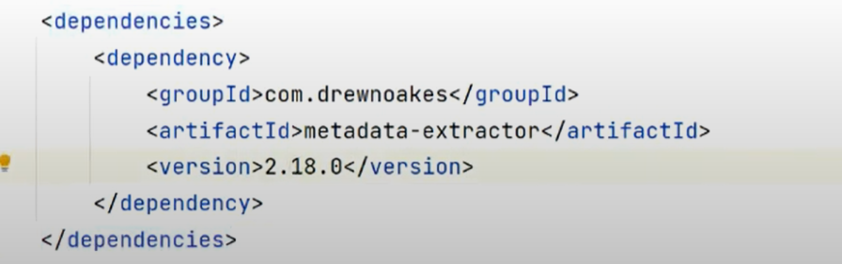

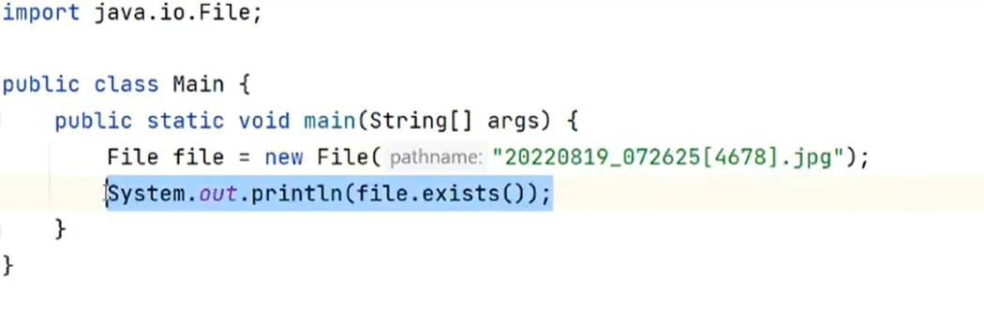

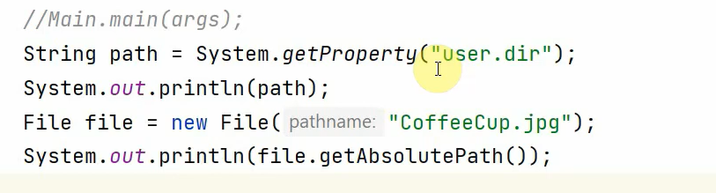

Derby

<https://www.youtube.com/watch?v=sOSa1DCL6rw&list=PLR2yPNIFMlL8e7NP-tsZ-XDfniK0XRS09>

<https://www.youtube.com/watch?v=cFFLcjrcU8s>

1/ Download Derb 10.15.2.0-bin

2/ Add the required jar to module/dependencies/

3/ add <https://mvnrepository.com/artifact/org.apache.derby/derby/10.15.2.0>

<https://mvnrepository.com/artifact/org.apache.commons.csv/commons-csv/1.0>

<https://www.baeldung.com/apache-commons-csv>

<https://blog.cacoveanu.com/2015/2015.07.03.20.13.csv.import.html>

<https://www.callicoder.com/java-read-write-csv-file-apache-commons-csv/>

<https://springhow.com/apache-commons-csv/>

public void ReadFromCSV() throws IOException {  
 String SAMPLE_CSV_FILE_PATH = "./productTableCSV.csv";  
  
 Reader reader = Files.*newBufferedReader*(Paths.*get*(SAMPLE_CSV_FILE_PATH));  
 CSVParser csvParser = new CSVParser(reader, CSVFormat.*DEFAULT* .withHeader("product", "country")  
 .withIgnoreHeaderCase()  
 .withTrim());  
  
 for (CSVRecord csvRecord : csvParser) {  
 // Accessing values by the names assigned to each column  
 String name = csvRecord.get("product");  
 String email = csvRecord.get("country");  
  
 System.*out*.println("Record No - " + csvRecord.getRecordNumber());  
 System.*out*.println("---------------");  
 System.*out*.println("Name : " + name);  
 System.*out*.println("Email : " + email);  
 System.*out*.println("---------------\n\n");  
 }  
  
  
}

public void Write2CSV() throws IOException { // this will overwrite  
 String SAMPLE_CSV_FILE_PATH = "./Write2productTableCSV.csv";  
 BufferedWriter writer = Files.*newBufferedWriter*(Paths.*get*(SAMPLE_CSV_FILE_PATH));  
 CSVPrinter csvPrinter = new CSVPrinter(writer, CSVFormat.*DEFAULT* .withHeader("ID", "Name", "Designation", "Company"));  
  
 csvPrinter.printRecord("2", "Sundar Pichai", "CEO", "Google");  
  
 csvPrinter.flush();  
  
}